For Sale- Industrial Building
130 N Belle Mead Rd
Setauket, NY

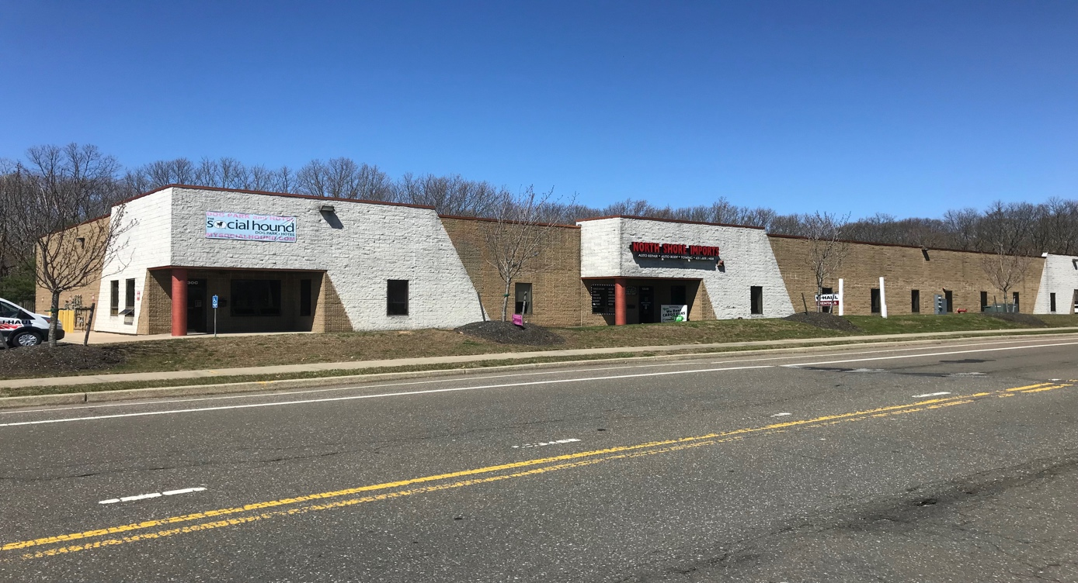

Building Size +/-16,000 Sqft (Divides into 3 Unit)
Lot +/-1.5Acres
Built 1985
Zoning L-1
Ceiling 18’ Clear
Loading 5 Overhead Doors
Parking 63 Cars
SCTM# 200-251-4
Property Highlights
All 3 Units Separately metered
Building very well-maintained
Possible User/Investor
Assumable Mortgage
All information submitted is subject to errors, omissions, change of price or rental, change of other terms and conditions, prior sale, lease, financing or withdrawal without notice. All areas and dimensions are approximate. This advertisement does not suggest that the broker has a listing on this property or properties or that any property is currently available
Perfect for 1031 Exchange
New Roof 2012
Building Strategically located in well known and Affluent Tech Park on very heavily traveled Belle Mead rd in Setauket
Close to Stony Brook Hospital & University

Property Taxes 2017-18 $36,814.71
Sale Price $2,500,000

Suffolk Industrial Properties, LLC
51 Cabot St, West Babylon, NY 11704
(646) 623-5242 Mike @suffolkindustrial.com
d

(646

